Written Assignment Unit 7
1. Find the length of an arc in a circle of radius 10 centimeters subtended by the central angle of 50°. Show your work.
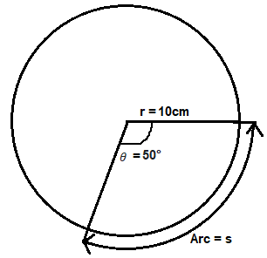
$$s=\frac{θ}{360°}×2πr$$
$$s=\frac{50°}{360°}×2π×10cm≈8.73 cm$$
2. Graph $f\left(x\right)=sinx$ on [-4π, 4π] and verbalize how the graph varies from the graphs of $f\left(x\right)=±x$.
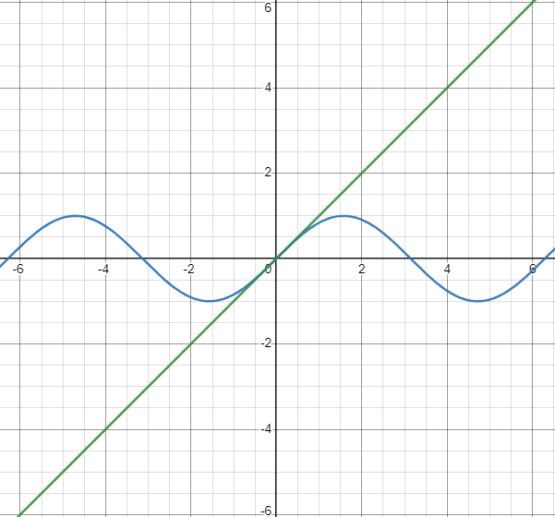
Comparing Graph $f\left(x\right)=sinx$ and $f\left(x\right)=±x$
$f\left(x\right)=sinx$ | $$f\left(x\right)=±x$$
Produce a sinusoidal wave | Produce a straight line
It oscillates between -1 and 1 | It has a constant slope
Period is $2π$, leading to repetitive | It extends infinitely in both directions

3. Graph $f\left(x\right)=\frac{sinx}{x}$ on the window [−5π, 5π] and describe freely what the graph shows. You can use www.desmos.com/calculator to obtain the graphs.
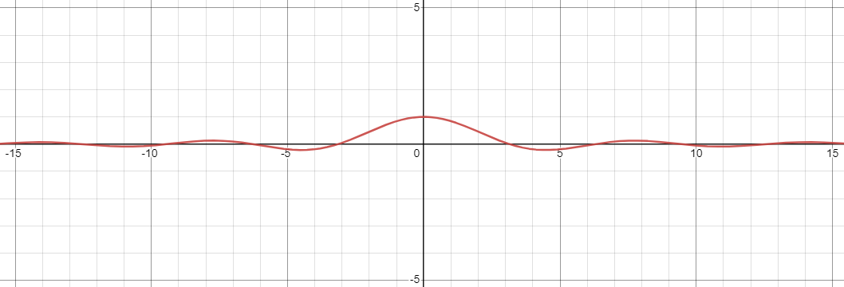
Describing the graph:
- As$x$ approaches 0 from either the left or right, the function approaches an asymptote, so there is a "hole" at the origin.
- The function is even, meaning that it is symmetric with respect to the y-axis.
- The amplitude of the function decreases as you move away from the origin. Near the origin, the graph is very "wavy" due to the rapidly changing sine function. As you move away from the origin, the oscillations become less pronounced.
- The graph will resemble a series of oscillations, with smaller and smaller oscillations as you move away from the origin. It will be symmetric about the y-axis, and you will see the asymptote at $x=0$. The function will have zeros at $x=nπ$ for integer values of $n$except for $n=0$. The interval $[-5π,5π]$ covers multiple periods of the sine function, and you'll see the repeating pattern of oscillations.
3. A 23-ft ladder leans against a building so that the angle between the ground and the ladder is 80°. How high does the ladder reach up the side of the building? Show the steps of your reasoning.
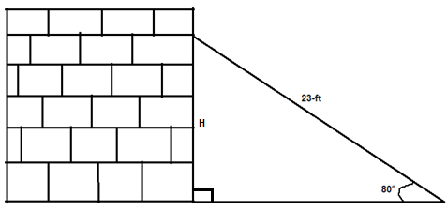
The ladder forms a right-angled triangle when leaning on the wall as shown above. There, trigonometric rations would be applicable to help determine the height (H) as follows:
$$sin θ=\frac{Opposite}{Hypotenuse}$$
$$sin 80°=\frac{H}{23ft}$$
$$H=sin 80°×23≈22.86ft$$

